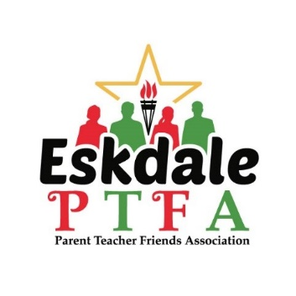

Thank you
Thank you to all that have registered as either a member of the PTFA or PTFA Lite. We would also like to Thank and welcome Krisha Warmby, who has kindly taken on the role of PTFA Events Officer. We cannot stress enough, without volunteers the events cannot go ahead, and crucial fundraising for the school impossible – so please, even if not registered with us, if you can help, please get in touch. We are pleased to announce our winner of the PTFA Member Prize Draw was Blessing.

50/50 Lottery
Congratulations to the
winners of the 50/50 Lottery.
The lucky winners received:
1st prize: Ticket 343: £46.25
2nd prize: Ticket 409: £27.75
3rd prize: Ticket 389: £18.50
Raising £88.43 for the PTFA.
The video of the drawer can be seen on our Facebook Page.
The 50/50 Lottery will return in the Spring Term.
Off to a Great Start!
What a fantastic start to the 2024/35 Year! Thank you all for your continued support. It has been great to be back in school, and back providing fun activities for the children. We raised a whopping £1157.65. We’ve got another fun packed half term ahead, keep an eye out for details of upcoming events on Parentmail.


As we approach Christmas, please remember to check whether you can raise us some pennies for the Eskdale PTFA whilst shopping online.

easyfundraising partners with over 7,000 brands who will donate part of what you spend to a cause of your choice. It won't cost you any extra. The cost is covered by the brand.

Please register and select to support ‘Eskdale Junior School PTFA’ to raise money for us as you shop!
http://efraising.org/IWg6Wf8fi6

Halloween Costume Sale
Thank you to all that attended the Halloween Sale, and for the few donations that we received. If you have any unwanted costumes now that Halloween is over please send them in. Due to the lack of donations this year, and having sold last years carried over stock, this will determine whether it is feasible to hold a sale next year. That said, we are pleased to announce that we collected £46.40 from the sale this year.
Please remember to send in your unwanted Halloween Costumes.

Non-Uniform
Who doesn’t love a non-uniform day! Thank you to those who took part, this raised a wonderful £195.65 which will be used to help buy supplies for future PTFA events for the children.

Colouring competition 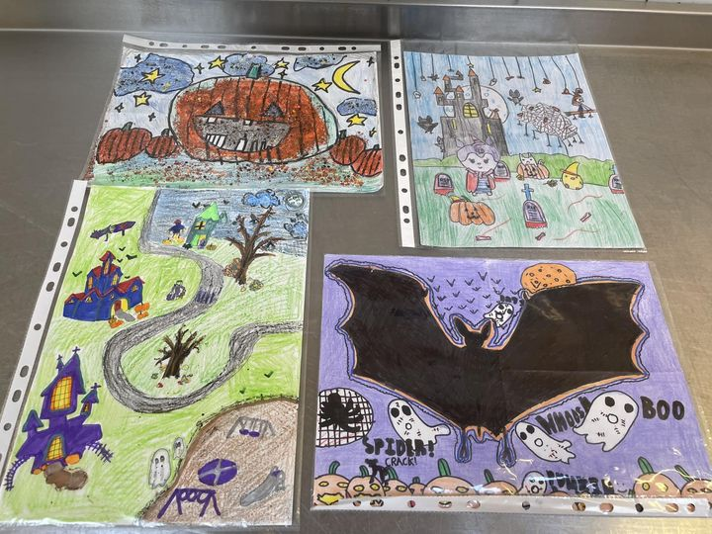
We had a wonderful array of entries again this year. The PTFA members found it a difficult task to pick the winners due to the high standards. Each entrant received a sweet treat for their efforts, and the winners were the proud owners of a spooky Halloween gift bag crammed full of eerie goodies. This fun little activity raised £40 for the PTFA.
🎄🔔 PTFA Calendar 🔔🎄
- Wed 21st Nov: Christmas Jumpers & Nearly New Toys Donations
- Wed 27th Nov: Last day for Christmas Jumpers & Nearly New Toys Donations
- Thurs 28th Nov: Christmas Jumpers & Nearly New Toys Sale
- Fri 29th Nov: Non-Uniform day for Christmas Raffle Donations.
- Mon 2nd Dec: Christmas Movie night
- Tues 3rd Dec: Christmas Movie Night
- Fri 13th Dec: Christmas Quiz Night

Halloween Disco
It was wonderful to see all the amazing costumes and the children having a great time at the Halloween discos. This event always proves popular. We are pleased to announce is raised a whopping £787.22.
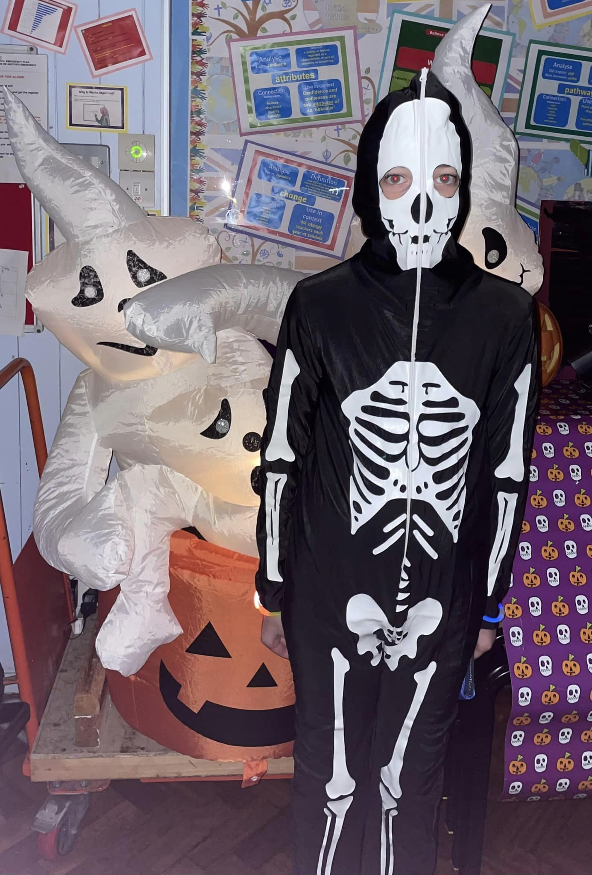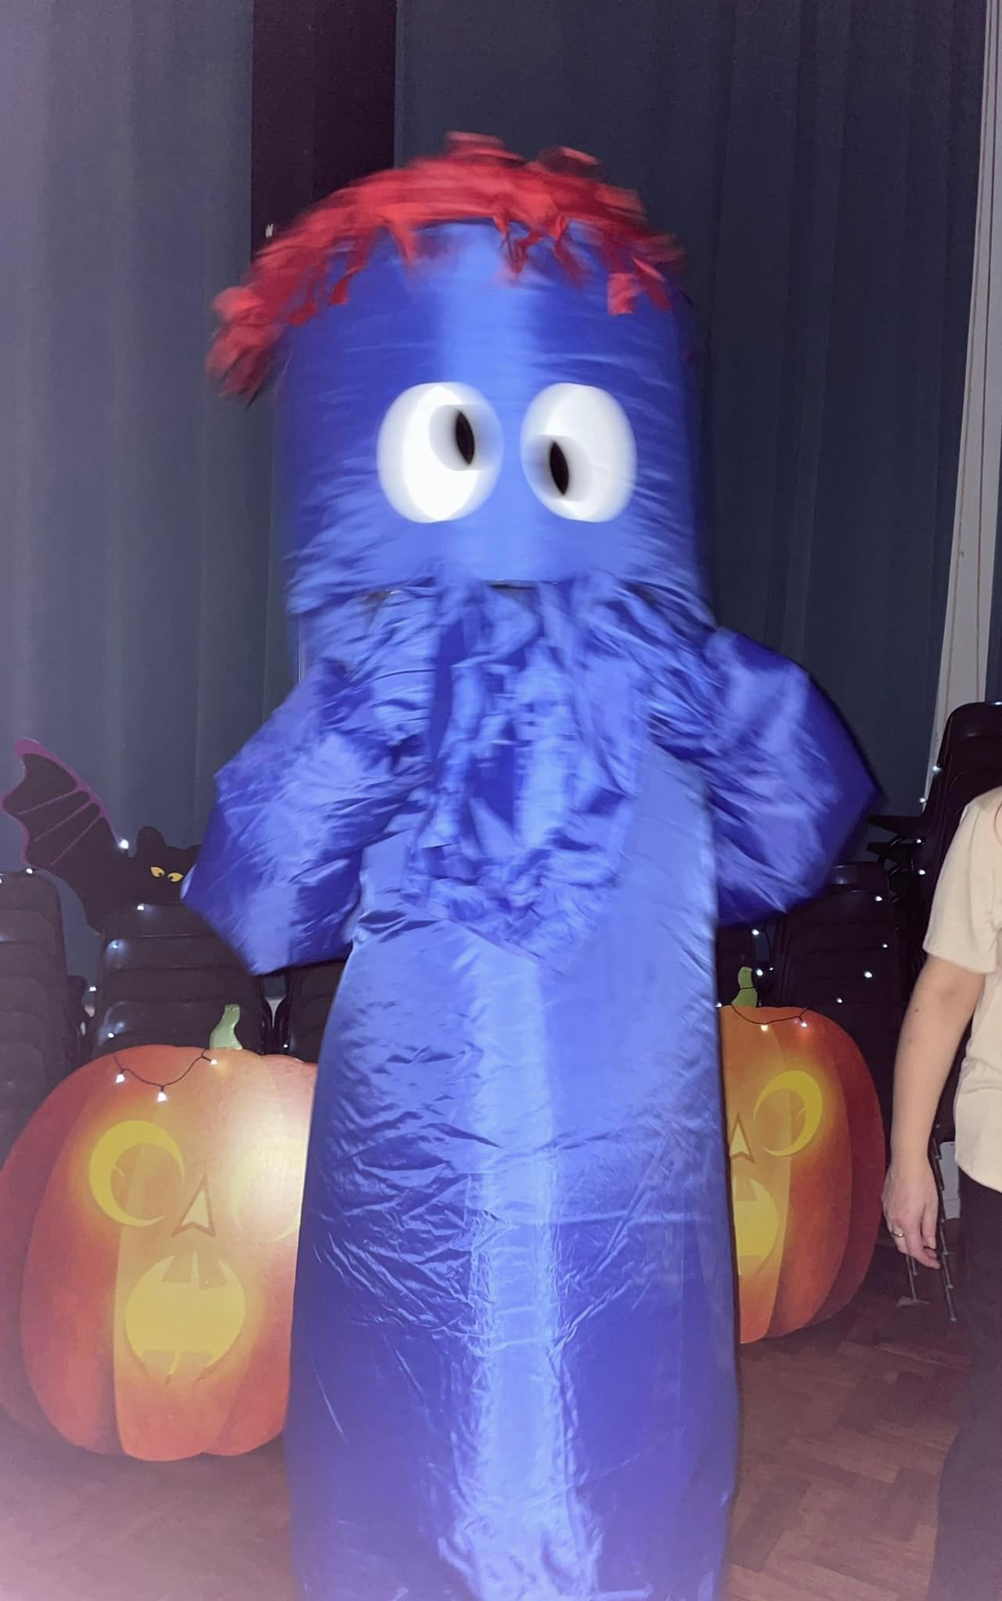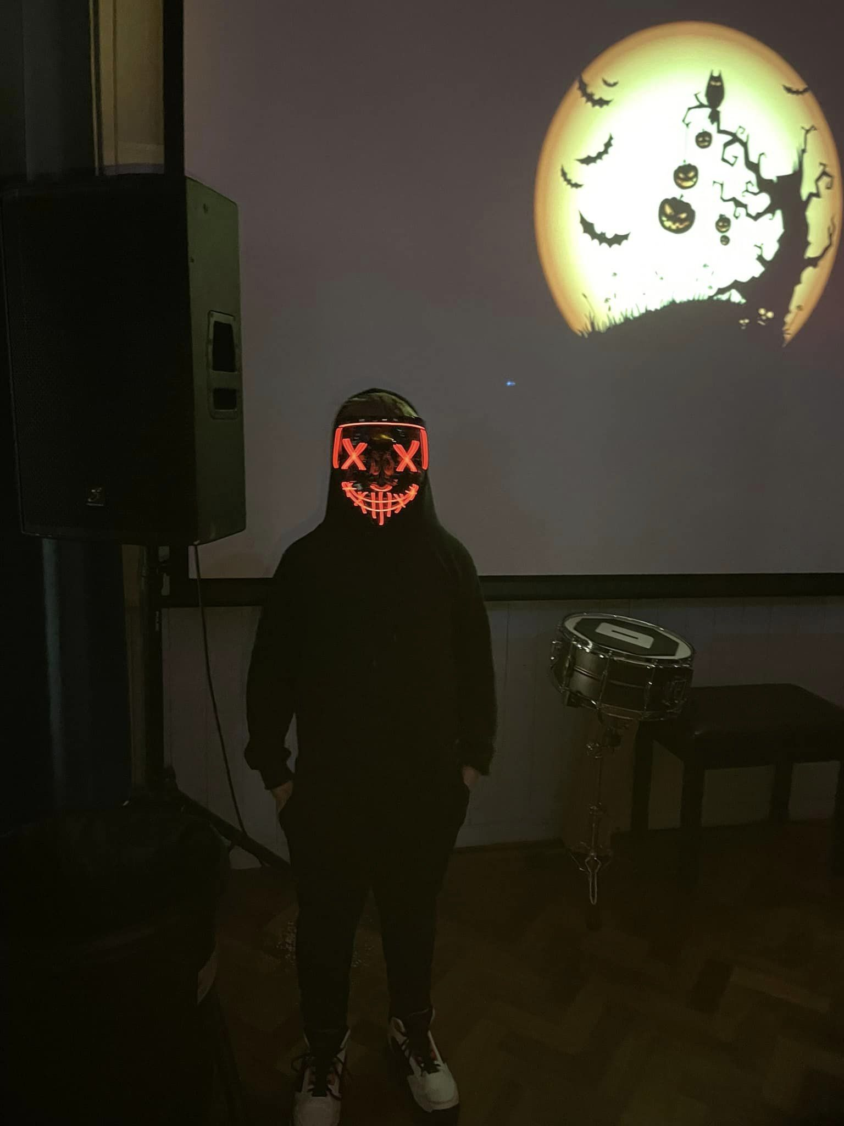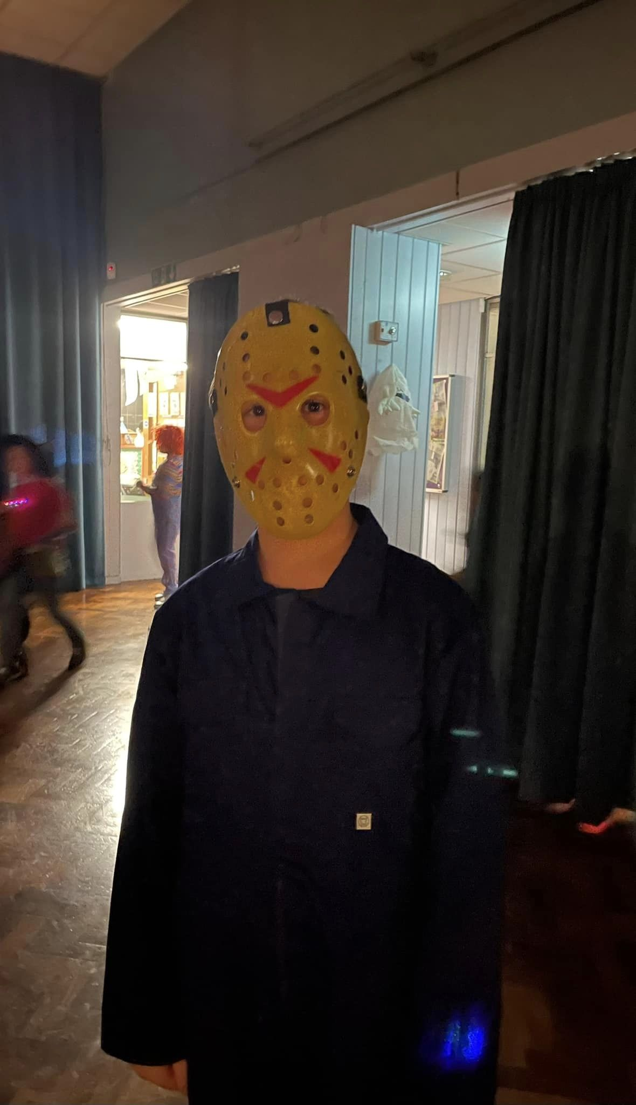

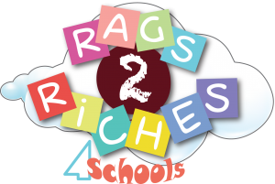


The collection box is in reception for you to drop off your used cartridges.

